Default localhost.cfg

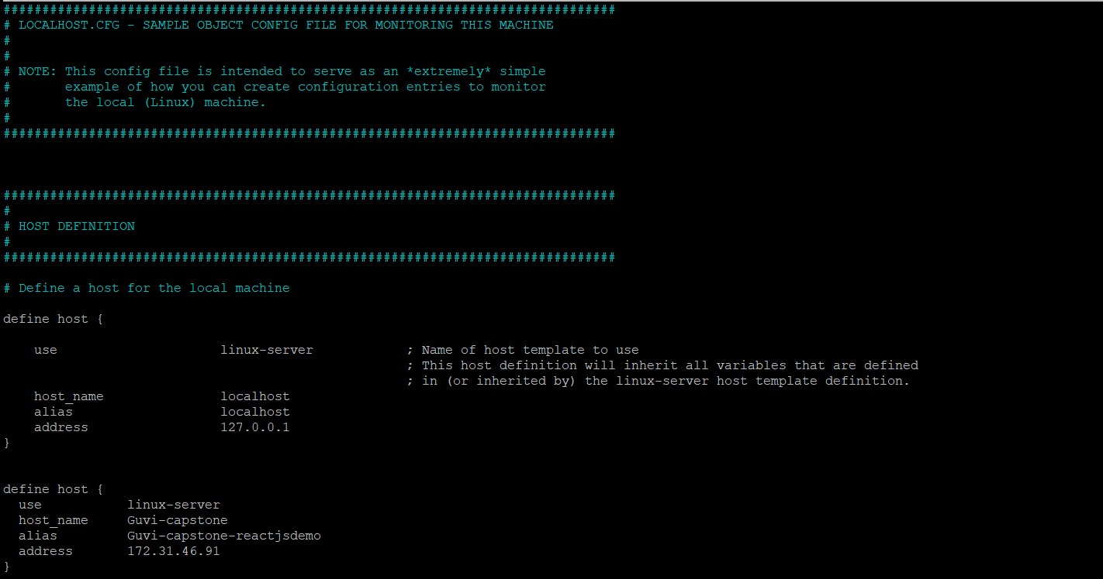

Add on :

define host {

use linux-server

host_name new-host

alias New Host

address 192.168.1.100 (enter private IP of reactjs server)

}

sudo /usr/local/nagios/bin/nagios -v /usr/local/nagios/etc/nagios.cfg

sudo systemctl restart nagios

